Energy “Story”

What story do we want to tell with energy?   
What does the book look like?

# What do they know from Unit 3?

* 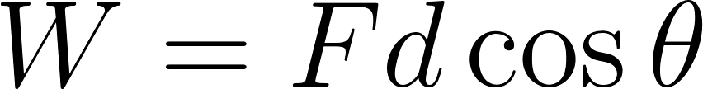
* Signs of work
* Work is area of F(x)
* They have heard of energy in other courses, and know that it is conserved
* Work has the units of energy

Unit 4 Introduction

# Reductionism and Emergence

*Take* [*http://umdberg.pbworks.com/w/page/68371403/Reductionism%20and%20emergence%20(2015)*](http://umdberg.pbworks.com/w/page/68371403/Reductionism%20and%20emergence%20(2015))

Chapter 12 - Introduction to the Microscopic World

# 12.0 Introduction

*Take:* [*http://umdberg.pbworks.com/w/page/68405576/The%20micro%20to%20macro%20connection%20(2013)*](http://umdberg.pbworks.com/w/page/68405576/The%20micro%20to%20macro%20connection%20(2013)) *with removing the last paragraph and adding what is below.*

In this chapter, we will look at some important properties of matter at the molecular scale such as the idea of a mole which you may know from a previous course. We will then develop molecule-based pictures of gases and solids. We will use these models of matter to help us to develop a coherent picture of energy that spans from our everyday world to the world of molecules.

# 12.1 Atomic structure and symbolism

*Take this from section 2.3 from OpenStax chemistry.*

# 12.2 The periodic table

*Take section 2.5 from OpenStax chemistry through figure 2*

# 12.3 What is a mole

*For this, let’s use section 3.1 from OpenStax Chemistry, removing only the two paragraphs at the top to make it flow*

# 12.4 The molecular picture of gases

## 12.4.1 The ideal gas law

*Section 13.3 removing the bit about moles (keeping the re-statement of ideal gas law in terms of moles). Also remove the bit at the end about the Ideal Gas Law and energy.*

## 12.4.2 Ideal gases vs. real gases

*Use* [*https://www.youtube.com/watch?v=3vGfWoPIstk&feature=youtu.be*](https://www.youtube.com/watch?v=3vGfWoPIstk&feature=youtu.be)

# 12.5 The molecular picture of solids

## 12.5.1 What is a solid

*Use* [*http://umdberg.pbworks.com/w/page/68393164/Solids%20(2013)*](http://umdberg.pbworks.com/w/page/68393164/Solids%20(2013)) *except the last paragraph*

## 12.5.2 The solid state of matter

*Use 10.5 from OpenStax chemistry here. Remove the part about defects. Also be sure to remove the discussion about lattice energies.*

## 12.5.3 Einstein solid

In this class, we will be focused on a model called the *Einstein solid* model of simple crystalline solids, particularly those where the atoms are arranged in simple cube-based structures such as table salt (NaCl) and copper as shown in Figure **A**. This model, named after Albert Einstein, is like the ideal gas law discussed in the previous section: almost no solid behaves exactly like an Einstein solid. However, the behavior of many solids is approximately Einsteinian and the principles behind the model can be used successfully to understand the more complex solids that you will probably study in your other science courses.

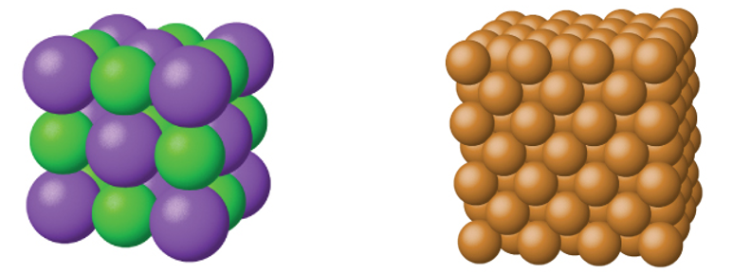

*Figure* ***A****: Both table salt (NaCl) on the left and solid copper on the right are simple crystalline solids with a cube-based structure.*

In the Einstein solid model, we model the bonds between each atom as tiny springs that obey the Hooke’s Law that we discussed in Unit 2. This model is shown in Figure **B**.While chemical bonds, like everything else, do NOT exactly obey Hooke’s Law, the modelling of atomic bonds as springs is very common throughout physics, chemistry, and biology. The reason this model is so common is that, for small shifts, atoms do behave as if they are on springs: pull two atoms in a crystal apart and the atomic bonds will pull them back together. If you push two atoms too close together, then the two positively charged nuclei will repel each other pushing them apart. The result is that each atom vibrates about its equilibrium position or *lattice site* as if it were attached to tiny springs. Given that calculations with Hooke’s Law are so simple to do in comparison to full calculations of atomic forces, you can see why this Einstein model is a useful approximation.

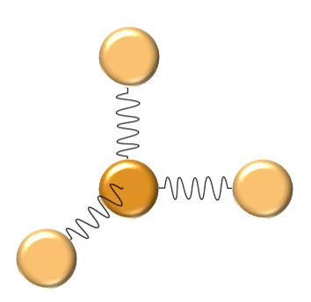

*Figure* ***B****: The model of an Einstein solid, the central atom is connected to its neighbors by atomic bonds that are modeled by springs that obey Hooke’s Law*

Chapter 13 - Introduction to Energy

# 13.1 Introduction - What *is* energy and how is it different from forces?

*Use video* <https://youtu.be/EXf5gtyKQ8Q>

# 13.2 Units of Energy

If energy is defined as the ability to do work, then energy and work must have the same units. Thus, the SI unit of the energy is the Joule (recall ). Energy, however, is one quantity where there are many other units in common use in scientific literature including electron-Volts (eV), kilowatt-hours (kW∙hr), calories, and Calories. In this course, we will be using Joules and electron-Volts exclusively. We are including these other units for your reference.

## Electron-Volts

A common quantity in chemistry is the electron-Volt or eV. One electron-Volt is the amount of energy gained by an electron as it travels between the two ends of a 1 Volt battery (a concept that will be discussed in more detail when you study electricity). Numerically, 1eV = 1.602×10-19J. The reason this unit is common in chemistry is that the energies of atomic bonds are typically about 1eV as shown in the table below[1]

|  |  |  |
| --- | --- | --- |
| Bond | Bond-dissociation energy at 298K (eV/Bond) | Comment |
| C-C | 3.60-3.69 | Strong, but weaker than C–H bonds |
| Cl-Cl | 2.51 | Indicated by the yellowish colour of this gas |
| H-H | 4.52 | Strong, nonpolarizable bond  Cleaved only by metals and by strong oxidants |
| O-H | 4.77 | Slightly stronger than C–H bonds |
| OH-H | 2.78 | Far weaker than C–H bonds |
| C-O | 11.16 | Far stronger than C–H bonds |
| O-CO | 5.51 | Slightly stronger than C–H bonds |
| O=O | 5.15 | Stronger than single bonds  Weaker than many other double bonds |
| N=N | 9.79 | One of the strongest bonds  Large activation energy in production of ammonia |
| H3C-H | 4.550 | One of the strongest aliphatic C–H bonds |

## Kilowatt Hours

When you buy electricity from the power company, the bill says how many kilowatt hours you have purchased. A Watt is a unit of a quantity called *power* and 1 Watt is equal to 1 Joule/second: 1W = 1 J/s. Thus, a kilowatt hour is:

## Calories and calories

The calorie is an imperial unit of energy that is still in common use in the nutritional sciences in the United States. One calorie (lowercase c) is the amount of energy needed to raise 1g of water 1oC or 1 cal = 4.814J. On food labels, you will see energy listed in Calories (capital C). One Calorie is equal to 1kilocalorie; in other words, 1 Cal = 1000 cal. Thus, one 1 Cal = 4814 J. In other countries, you will see food labels in both Calories and Joules like the one shown in Figure **A[2]**.



*Figure* ***A****: A food label from the UK showing the energy of the food in both Joules and kcal (or Calories).*

# 13.3 Types of Energy and Scales of Energy

Fundamentally, there are only two kinds of energy: kinetic energy and potential energy*. Kinetic energy (K) is the ability to do work associated with motion and potential energy (U) is the ability to do work arising from the relative positions of objects.* As an example, the car in motion in the left image of Figure **B** has the capability to do work due to its motion - the car has *kinetic energy*. If the car were to crash, then a force would be exerted over a distance deforming the car (right image in Figure **B**). The sheer fact that the car is moving means that it *can* do work. Similarly, the larger block in Figure **C** could do work if the system were released. As the large block fell, it would lift the small block. The large block has *potential energy* - an ability to do work due to its position relative to the earth.

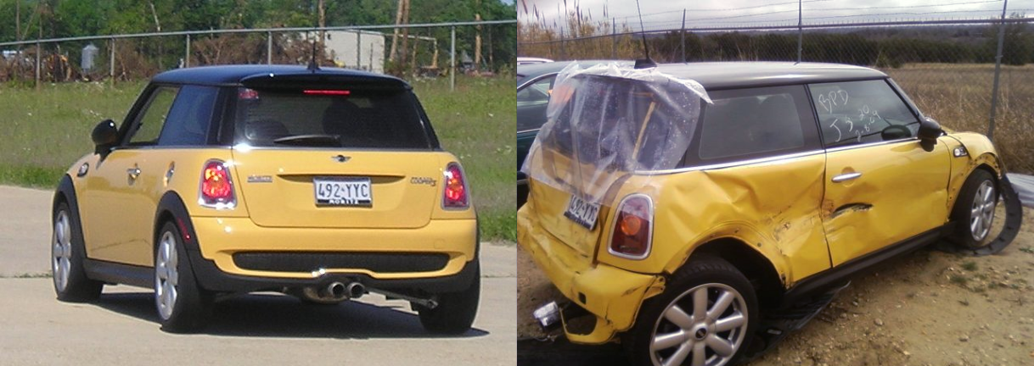

*Figure* ***B****: A car traveling down the road (left) has an ability to do work due to its motion - it has kinetic energy. We see that ability to do work when the car crashes (right) - a force acts for a distance deforming the car. [3]*

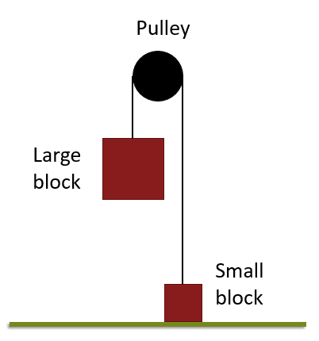

*Figure* ***C****: A large block connected to a small block over a pulley has an ability to do work due to its position relative to the earth; the large block has potential energy. We see that work when the large block is released exerting, via the rope and pulley, a force on the small block for a distance causing it to accelerate upwards.*

All of the many different types of energy that you have heard about in previous courses, thermal, chemical, electrical, etc., all ultimately boil down to these two different types. You may be wondering how chemical and thermal energy can be potential or kinetic. Typically when we think of kinetic energy, we think of the motion of people, cars, and the like! The key is to think about the *scale* of the energy: are we talking about energy at the macroscopic scale (people etc.) or the microscopic scale (atoms and molecules)? As we shall see, thermal energy is just kinetic energy on the microscopic scale and chemical energy is potential energy on the microscopic scale. The relationships between these types of energy can be seen in Figure **D**. One of our goals throughout these chapters on energy is to develop a coherent picture of energy that applies at both the macroscopic scale of people etc. and at the microscopic scale of atoms and molecules. Thus, while we may present the macroscopic and microscopic scales in two separate chapters, keep in mind that we are talking about the same idea of energy throughout. At the end, we will look at how to transfer energy between these two different scales.

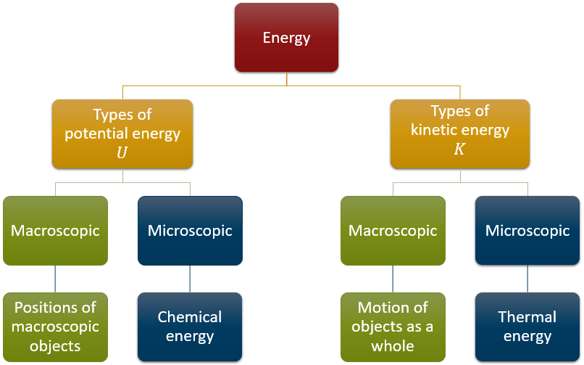

*Figure* ***D****: The relationships between different types of energy*

# 13.4 Conservation of Energy

You probably have heard from other courses that “energy is conserved.” This statement is true, for the Universe as a whole - the total amount of energy has not changed since the birth of the Universe 13.6Gyr ago. While this is a hugely important fact which gets deep into the heart of physics, it may not seem very useful. However, there is an, equally fundamental, and more useful fact: the amount of energy in any given system is conserved: the energy at the end of some process is what I had at the beginning plus any that came in minus any that went out, or in equation form: .

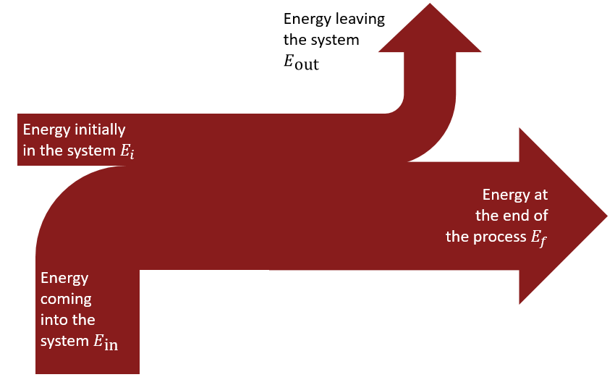

*Figure* ***E****: The conservation of energy in graphical form*

# 13.5 Ways to Transfer Energy

So what ways are there to transfer energy into or out of a system? Well we already know of one way: work. If we do positive work on a system (the force we apply is in roughly the same direction as the displacement), then we will add energy *in*. Conversely, if we do negative work on a system (force essentially opposing the displacement) then energy is leaving the system. This should make some intuitive sense: we expect for positive work that the object will speed up - the object will gain kinetic energy. On the other hand, if we do negative work, we expect that the object will lose kinetic energy.

There is another way to transfer energy into or out of a system: heat which we represent by the letter . At its core, *heat is the transfer of energy by collisions at the microscopic scale*.

*Use* [*https://youtu.be/95AUDZn9bZo*](https://youtu.be/95AUDZn9bZo)

# 13.6 The Formal Statement of the Conservation of Energy as the First Law of Thermodynamics

In section 13.4, we stated that energy must be conserved: . Moving things around we get . Recognizing the term on the left as , we can say . If we redefine and as just different directions of transferred energy , then we have where is positive if energy comes into the system and negative if energy is leaving the system. Now, we know that there are two different ways to transfer energy into or out of a system: heat and work. Thus, must be the sum of the energy transferred by heat and the energy transferred by work, . The statement of the law of conservation of energy can therefore be written as

.

Written in this form, the law of conservation of energy is called the *First Law of Thermodynamics*, i.e. the First Law of Thermodynamics and the Law of Conservation of Energy are the same thing.

This statement is so fundamental to the idea of physics that it is worth spending a minute to really unpack what it says. Looking again at the First Law of Thermodynamics (with the delta expanded) we see

where both heat and work are ways of *transferring* energy into or out of the system. As a first example, say we have some system and we do work on that system without transferring any energy as heat. In this case, as energy is coming in and . The result is that , which makes sense as we have added energy. Similarly, if we had a system that is losing heat to its environment while remaining stationary at constant volume then we know that because heat is flowing out and due to the fact that there is no “distance” for . Therefore, and as expected given that energy is flowing out of the system.

# 13.7 Why the First Law of Thermodynamics May Look Different in Your Other Courses

In some other courses or references, you may see the first law of thermodynamics written as , i.e. the sign of work may be different. This is still the same First Law of Thermodynamics/Law of Conservation of Energy that we are talking about here. The difference is one of perspective. In this class, we are considering energy flowing into the system as positive and energy flowing out of the system as negative. This convention matches our convention for heat as well as matching our definition of work from mechanics which considers only external forces. Physically, we are thinking about work done *on* the system by *external* forces.

To understand the formulation, you need a bit of history. The Laws of Thermodynamics were formulated during the Industrial Revolution as people were studying the properties of steam engines and the like. When studying the performance of a steam engine, the interesting quantity is not the work done *on* *the system by* *external* forces, but instead the work done *by the engine on its environment*. Stated another way, the developers of the Laws of Thermodynamics were not using our idea of object egoism! Instead of thinking about , they were thinking about . Now by Newton’s Third Law, these two forces are equal except for a negative sign. Thus, when you think about work done *by* the engine instead of the work done *on* the system, work flips sign and you end up with instead of .

In this class, we will stick with , i.e. we will use the same definition for work we have been using. The takeaway from this section is that you may see the First Law of Thermodynamics written with a different sign for work. Different fields use different conventions (it would be nice if we could agree, but oh well). Therefore, you should be aware that writing it as is just a different perspective born out of the historical development of science. This quirk with the sign of work is a great example of the impact that history and all of its associated socio economic factors can have on the history of science. One wonders what other ideas could be expressed more coherently? What scientific questions have not been explored because the people in power doing the research did not value them?

# 13.8 Enthalpy

*The following is a modification of content from 5.3 in OpenStax Chemistry*

Chemists and biologists often use enthalpy (*H*) to describe the thermodynamics of chemical and physical processes instead of the energy (*E*) and you may have seen this quantity before. Both enthalpy and energy have the same units and the words are similar so students often confuse these two ideas. However, while enthalpy and energy are related, enthalpy is not the same thing as energy. Energy is the ability to do work. Enthalpy is defined as the sum of a system’s microscopic or internal energy (*E*) and the mathematical product of its pressure (*P*) and volume (*V*):

*H*=*E*+*PV*

Enthalpy values for specific substances cannot be measured directly; only enthalpy *changes* for chemical or physical processes can be determined. For processes that take place at constant pressure (a common condition for many chemical and biological processes due to the fact that they are open to the air which is at a constant pressure of 1 atm), the enthalpy change (Δ*H*) is:

Δ*H*=Δ*U*+*P*Δ*V*

Recall from the chapter on work that the mathematical product *P*Δ*V* represents work (*W*). If I compress the a gas in **FIGURE**, we see that the work is positive (the applied force is in the same direction as displacement of the piston) and energy is flowing into the system. However, the volume of the gas is shrinking. This example illustrates the general concept that the arithmetic signs of Δ*V* and *w* will always be opposite:

*P*Δ*V*=−*W*

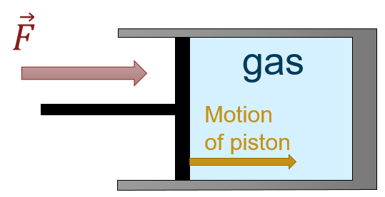

**FIGURE:** *A gas being compressed by a piston. The force on the piston is in the same direction as the piston’s motion implying positive work. However, the volume of the gas is shrinking meaning*

Substituting this equation and the definition of internal energy into the enthalpy-change equation yields:

Δ*H*=Δ*E*+*P*Δ*V*

Δ*H*=(*QP*+*W)*−*W*

Δ*H*=*QP*

where *QP* is the heat of reaction under conditions of constant pressure. **Thus, if a chemical, biological, or physical process is carried out at constant pressure with the only work done caused by expansion or contraction, then the heat flow (*QP*) and enthalpy change (Δ*H*) for the process are equal.**

This condition, while it may seem restrictive, covers a significant fraction of the situations you will encounter. For example, the heat given off when you operate a Bunsen burner is equal to the enthalpy change of the methane combustion reaction that takes place, since it occurs at the essentially constant pressure of the atmosphere. On the other hand, the heat produced by a reaction measured in a bomb calorimeter ([[link]](https://cnx.org/contents/85abf193-2bd2-4908-8563-90b8a7ac8df6@9.480:0d364b67-be96-44fc-bee5-a368a42c2c82@11#CNX_Chem_05_02_BombCalor)) is not equal to Δ*H* because the closed, constant-volume metal container prevents expansion work from occurring. Chemists and biologists usually perform experiments under normal atmospheric conditions, which results in a constant external pressure making *Q* = Δ*H*.

*Note to David: leave that link to the bomb calorimeter*

Chapter 14 - Energy of Objects as a Whole (Macroscopic Scale)

For starters, it is simpler to think about energy of objects as a whole at the macroscopic scale separate from the collective energy of the constituent molecules. This thinking is in line with the physics problem solving approach of starting simple and adding complications later. The next chapter deals with energy at the microscopic realm. We will get into connecting these two realms in class. We shall see that there are only specific ways of transferring energy between the macroscopic world and the microscopic world so separating these two regimes makes sense. As you know from the previous chapter, heat is the transfer of energy by microscopic collisions. *Thus, heat is really only important at the microscopic scale and will not be considered in this chapter.*

# 14.1 Kinetic Energy of an Object

*David: This section is modified from 7.2. I have made some edits throughout that I am highlighting in bold. This is due to the fact that we are starting from a place where the concept of conservation of energy is assumed (chapter 13).*

**Our goal in this section is to figure out an expression for the kinetic energy.**

## 14.1.1 Figuring Out the Expression for Kinetic Energy

**To achieve this objective, let’s begin our study of energy with, as usual the simplest possible situation. Consider** a one-dimensional situation where a force is used to accelerate an object in a direction parallel to its initial velocity. Such a situation occurs for the package on the roller belt conveyor system shown in [Figure](https://cnx.org/contents/Ax2o07Ul@9.86:P_-6tVsN@5/Kinetic-Energy-and-the-Work-En#import-auto-id1803210).

*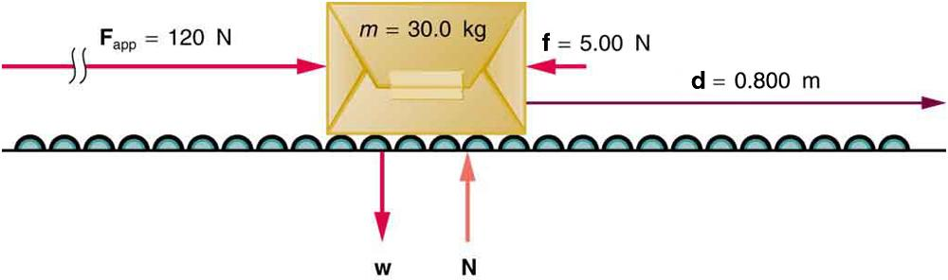 A package on a roller belt is pushed horizontally through a distance* ***d****.*

**In this case, there is no transfer of energy by molecular collisions, i.e. there is no heat and . Meaning that our statement of conservation of energy goes from**

**to**

**Similarly, there is no ability to do work due to position; the box cannot fall because of the rollers. Thus, there is no potential energy in this problem and all of our energy is kinetic energy: . Therefore, our statement of conservation of energy for this situation is just**

**.**

**The effect of the net force Fnet is to accelerate the package from *v*0 to *v*. The kinetic energy of the package increases, indicating that the net work done on the system is positive. (See** [**Example**](https://cnx.org/contents/Ax2o07Ul@9.86:P_-6tVsN@5/Kinetic-Energy-and-the-Work-En#fs-id1703845)**.) By using Newton’s second law, and doing some algebra, we can reach an expression for kinetic energy.**

The force of gravity and the normal force acting on the package are perpendicular to the displacement and do no work. Moreover, they are also equal in magnitude and opposite in direction so they cancel in calculating the net force. The net force arises solely from the horizontal applied force **F**app and the horizontal friction force **f**. Thus, as expected, the net force is parallel to the displacement, so that *θ*=0º and cos*θ*=1, and the net work is given by

*W*net=*F*net*d*.

**Substituting *F*net=*ma* from Newton’s second law gives**

***W*net=*mad.***

**To get a relationship between net work and the speed given to a system by the net force acting on it, we take *d*=*x*−*x*0**

**and use the equation studied in** [**Motion Equations for Constant Acceleration in One Dimension**](https://cnx.org/contents/031da8d3-b525-429c-80cf-6c8ed997733a@9.86:ea2bb23c-4fce-4e9d-a46b-3754125da988@9) **for the change in speed over a distance *d* if the acceleration has the constant value *a*; namely, *v*2=*v*02+2*ad* (note that *a* appears in the expression for the net work). Solving for acceleration gives *a*=*v*2−*v*022*d*. When *a* is substituted into the preceding expression for *W*net, we obtain**

***W*net=*m*(*v*2−*v*022*d*)*d*.**

**The *d* cancels, and we rearrange this to obtain**

***W*net=12*mv*2−12*mv* 20.**

## 14.1.2 Interpreting the Result: Kinetic Energy

*David: This section is taken from* [*http://umdberg.pbworks.com/w/page/68405433/Kinetic%20energy%20and%20the%20work-energy%20theorem%20(2013)*](http://umdberg.pbworks.com/w/page/68405433/Kinetic%20energy%20and%20the%20work-energy%20theorem%20(2013)) *with a few edits*

What has come out after all our manipulations is a that the work in this case is related to a change in a quantity associated with motion, ½*mv*2. This is kind of like momentum in that it counts both the mass and the velocity, but it differs in that momentum is proportional to the velocity vector -- so it is very directional. Reversing momentum is a big deal even if the speed doesn't change. For our new quantity, since it is proportional to *v*2 instead of to *v*, the direction of motion doesn't matter. You get the same *v*2 whether *v* is positive or negative. If our general result turns out to only depend on the magnitude of *v* and not the direction (it will), we will have solved our problem and learned what it is that changes an object's speed (not caring about direction).

When you compare the result of our manipulations to our analysis in terms of energy, you can see that ½*mv*2 must be the ***kinetic energy*.** It is a measure of "the energy associated with how much an object is moving".

# 14.2 Examples Applying Conservation of Energy with only Kinetic Energy

## 14.2.1 Calculating Kinetic Energy

*Use “Calculating the Kinetic Energy of a Package” example from 7.2*

## 14.2.2 Kinetic Energy Depends on the Square of the Velocity

*Make this look like the rest of the example problems.*

### Problem

A car travels at 5m/s when it accelerates to 10m/s. After the car has finished accelerating, by what factor did its kinetic energy increase?

### Solution

We are interested in the ratio of the final to the initial kinetic energies

Substituting our definition for kinetic energy we get

Since the mass of the car does not change, and the cancel leaving

Substituting our values in we get

### Analysis

The speed went up by two, but the kinetic energy went up by a factor of four, a result consistent with the fact that kinetic energy depends upon the square of the velocity. Speed matters a lot when thinking about energy!

## 14.2.3 Application of Conservation of Energy with Only Kinetic Energy

*Use a video of Heath’s that I am editing here*

<https://youtu.be/AEQUryH-twA?list=PLdIHHDayjYIK0G-CbsXZFt_JvX37tuAMD>

(should be under 5min)

# 14.3 Macroscopic Potential Energy

## 14.3.1 Gravitational Potential Energy

*For this use section 7.3 through the Kangaroo example. Swap PE → U and KE → K throughout. Also be sure to remove the parenthetical reference to the work energy theorem in the first paragraph of* ***Converting Between Potential Energy and Kinetic Energy***

## 14.3.2 The Zero of Gravitational Potential Energy

<https://youtu.be/WSsO1vs-dpY?list=PLdIHHDayjYIK0G-CbsXZFt_JvX37tuAMD>

## 14.3.3 Potential Energy of a Spring

*For this use the* ***Potential Energy of a Spring*** *subsection of 7.4. Again make sure to swap PE → U*

# 14.4 Conservative vs. Non-Conservative Forces

<https://youtu.be/BmbLjnU77z8?list=PLdIHHDayjYIK0G-CbsXZFt_JvX37tuAMD>

# 14.5 Conservation of Energy of an Object as a Whole (Conservation of Mechanical Energy)

Now we have all of the different types of macroscopic energy that we will talk about in this course: kinetic energy , gravitational potential energy , and the potential energy of a spring . These different types of energy can be organized as in the chart in the **FIGURE**. Collectively these types of energy are called *mechanical energy.*

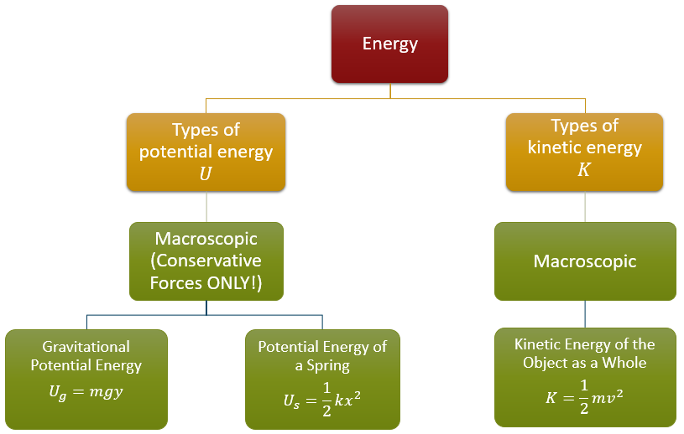

***FIGURE:*** *The different types of macroscopic (also called mechanical) energy*

Using these forms, and noting that heat is a microscopic process, we can write the law of conservation of energy as

.

Where the work is the energy transferred into or out of the system by non-conservative forces. Knowing that the total energy is the sum of potential and kinetic energies, we can say that

which many people rearrange to look like

as this formulation separates the initial and final conditions. Finally, we could replace the potential energy with the types of potential energy are possible at the macroscopic scale: gravitational and springs. Such a replacement would leave us with

where is, for example, the initial gravitational potential energy.

This particular final form is very useful for analyzing situations in terms of energy. All we need to do to get started is:

1. Identify what types of energy we have in a given situation
2. Substitute the expressions for the gravitational potential energy , spring potential energy , and kinetic energy
3. Think about any energy entering or leaving the system as non-conservative work

The next section has some examples of this process for the special case where the energy entering or leaving the system as non-conservative work is zero; situations where the mechanical energy is conserved. These are the types of problems that we will expect you to be able to do on your homework and quiz. We will address the situation where energy is entering or leaving the system in class.

# 14.6 Examples where Mechanical Energy is Conserved

<https://youtu.be/8SrC6hiOodYv>

## 14.6.1 Kingda Ka

<https://youtu.be/Zrp-W5GM_58?list=PLdIHHDayjYIK0G-CbsXZFt_JvX37tuAMD>

## 14.6.2 Wrecking Ball

<https://youtu.be/S40uRk8ENU8?list=PLdIHHDayjYIK0G-CbsXZFt_JvX37tuAMD>

## 14.6.3 Example with a spring

<http://umdberg.pbworks.com/w/page/89285639/Energy%20conservation%3A%20Example%201>

# 14.7 Graphical Tools for Analyzing Situations Using Energy

As we have seen throughout this course, being able to represent concepts in multiple formats can be useful. Throughout the course, we have represented ideas in words, equations and graphs. Graphical representations can also be a useful way of analyzing situations involving energy, albeit we will need a new type of graph: a pie chart.

Pie charts are particularly useful in the, common, case where there is little to no energy entering or leaving the system of interest. In these cases, the total amount of energy is constant and the only changes are from one form of energy to another. The quantity of interest is then: what fraction of the total energy is in each form? Representing such fractions of a whole is the strength of the pie chart.

## 14.7.1 A First Example

### Problem

The use of pie charts is probably best illuminated by an example. As per the usual approach in physics, we will start with the simplest possible case to get the fundamental principles and then add complications. Consider the case of a ball being dropped straight down as in **FIGURE**. We will only look at the situation before the ball hits the floor and ignore any impacts of air resistance. Let’s think about the energy for the four instants shown:

1. The instant the ball is released
2. A short time after the ball
3. Halfway to the ground
4. Just before the ball hits the ground

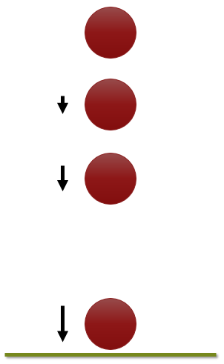

***FIGURE:*** *A ball falls from a height. Four instants in the fall are shown: the ball as it is just released, the ball after falling a short distance, the ball after falling ½ the way, and the ball just before it hits the ground. The arrows to the side get longer to represent that the ball is moving faster as it falls.*

### Solution

1. The instant the ball is released the ball is not moving at all and therefore has no kinetic energy. All of the ball’s energy is gravitational potential energy. We would represent this with a simple pie chart showing 100% of the energy as gravitational potential energy

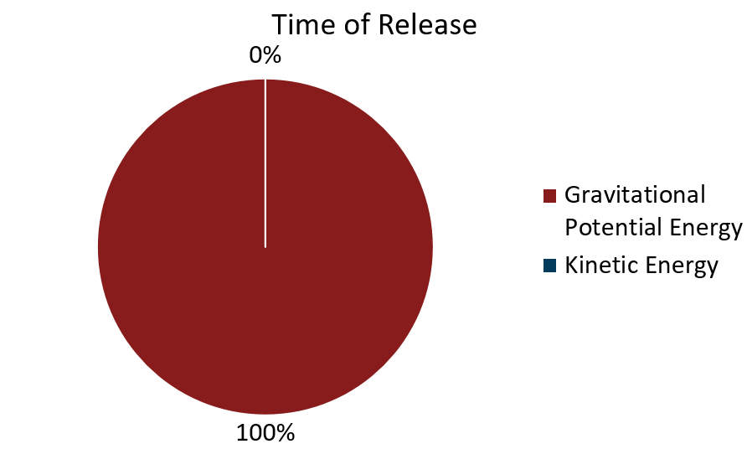

1. A short time after the ball is released, the ball has gained a little bit of kinetic energy, but most of the energy is still gravitational potential energy. Now, not enough information was provided to be quantitative, but we can say that most of the pie should still be gravitational potential energy and our graph might look like the one below.

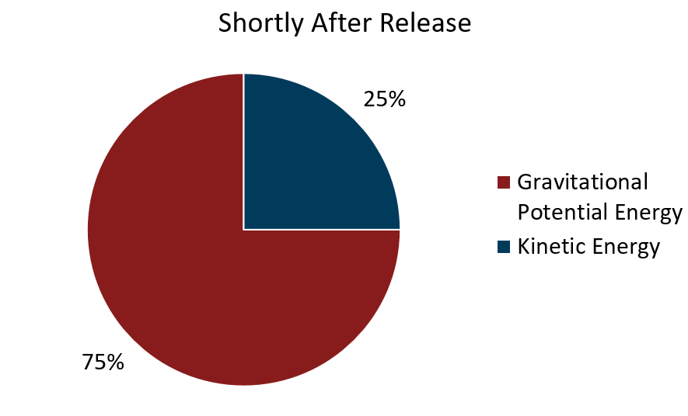

1. When the ball is halfway to the ground we can be a bit more specific. Initially the ball was at some height , and therefore had an initial gravitational potential energy . Now that the ball is halfway to the ground, the height must be and the gravitational potential energy is or ½ of its initial value. Since the total energy must be constant, the rest of the energy MUST be kinetic and we end up with a pie chart that is 50% potential energy and 50% kinetic energy as shown.

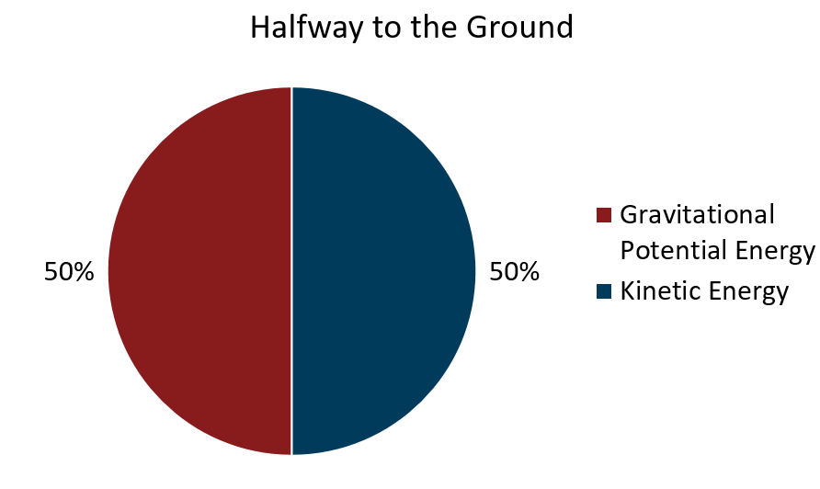

1. At the instant before the ball hits the ground, the height of the ball is essentially zero and therefore the ball has no more potential energy and all of its energy must be kinetic. Therefore, at this instant, we get a pie-chart that is 100% kinetic energy as shown.

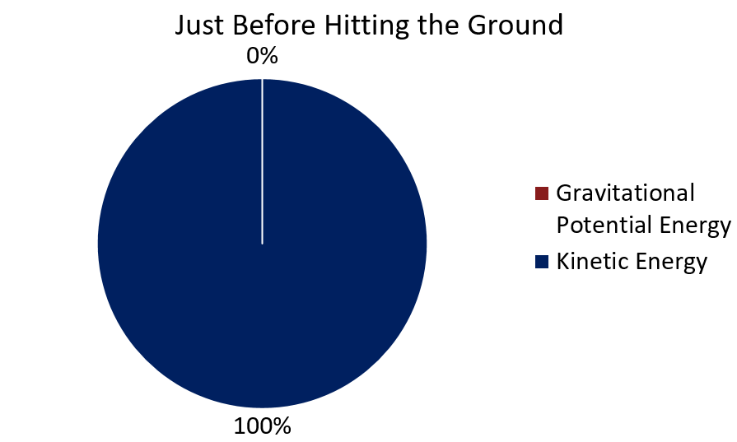

## 14.7.2 Another Example with Two Objects

### Problem

In this case, we have two objects of unequal mass tied together over a frictionless pulley as shown. The heavier object is suspended above the ground on which the lighter object, which has half the mass rests. Draw the energy pie charts for:

1. The initial condition
2. The situation where the large mass has fallen halfway to the floor and the small block has, due to the fact that they are tied together, risen the same distance.

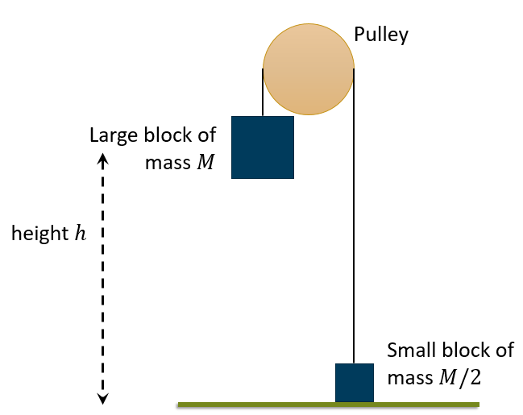

***FIGURE:*** *The setup for this example as described in the text where the large block of mass is suspended a height above the ground on which a small block of mass rests.*

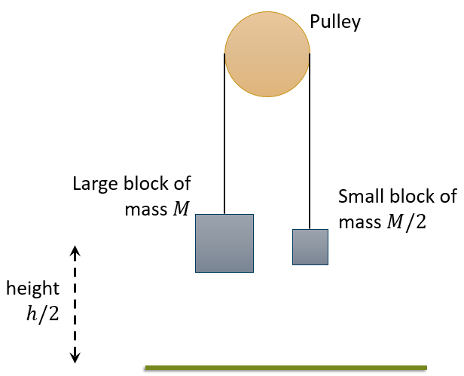

***FIGURE:*** *The final condition of the situation of interest, the large block has fallen half of its initial height while the small block has, because they are tied together, risen the same distance.*

### Solution

1. For the initial conditions, all of the energy is in the gravitational potential energy of the large block. The total energy in the system is

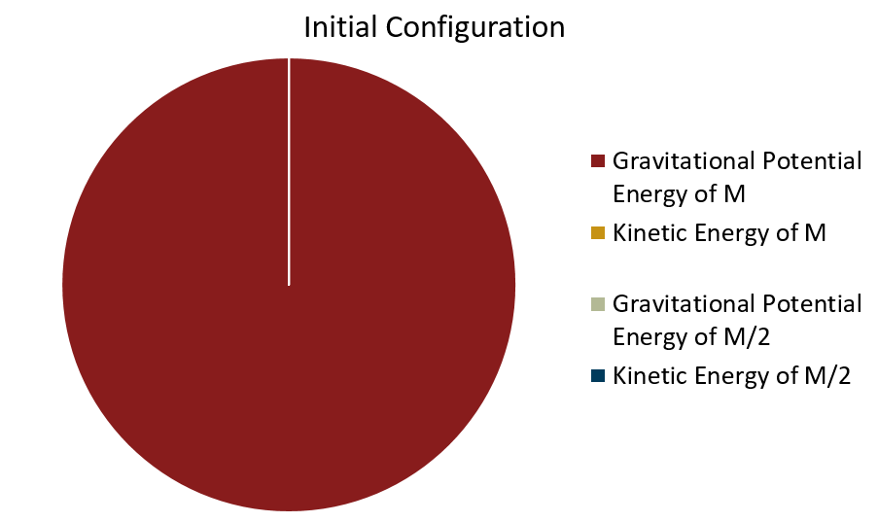

1. This situation is a bit more interesting and it would be best to look at the different elements of the system one at a time. Remember the total energy of the system cannot change and is   
     
   Potential Energy of : The block is now at which means that its potential energy is now which is half the total energy of the system so the potential energy of should be 50% of our pie.   
   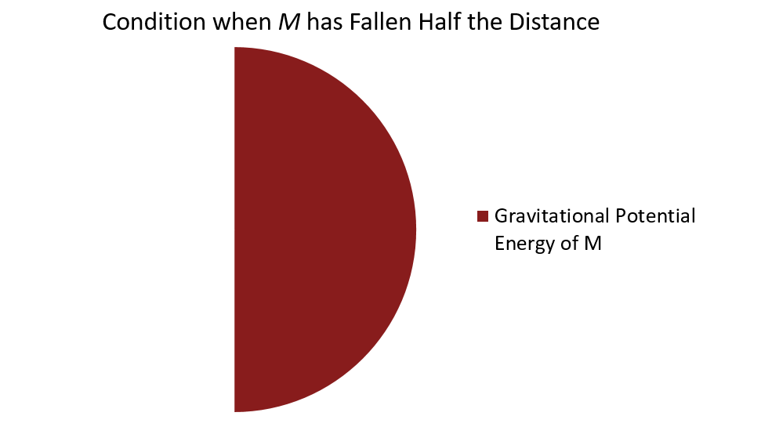  
     
   Potential Energy of : This block has risen (the distances must be the same as the two blocks are tied together). Thus, the potential energy of this block is now or ¼ of the total. Thus the potential energy of should be 25% of our pie.   
   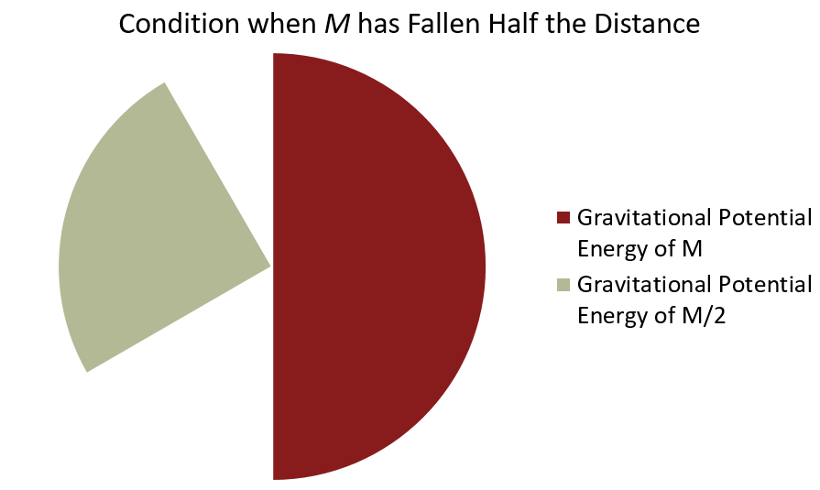  
     
   This leaves the two kinetic energies, which by conservation of energy MUST add up to 25% of the total. Moreover, the two blocks MUST be going at the same speed (again, because they are tied together). However, the two blocks do NOT share the kinetic energy equally. The block is twice the mass of the block ! If the two kinetic energies add up to 25%, then we have   
   .  
   Knowing that and substituting we can see   
     
     
     
   or should be 16.67% of our pie! Finally, must be half of that or 8.33%. The result is the final pie shown below

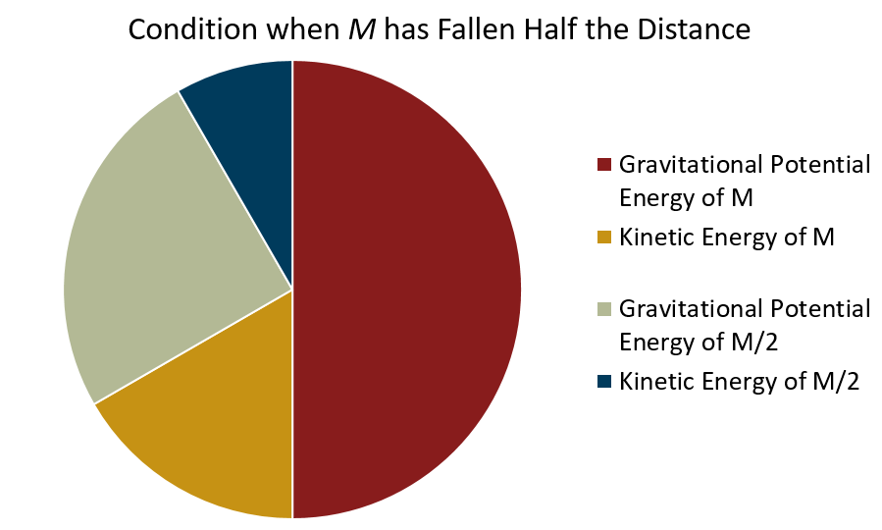

## 14.7.3 How Energy Pie Charts can be Used to Analyze Situations (Take-away)

Energy pie-graphs are a useful tool to analyze situations in terms of energy. The pie graphs can be used to:

* Make sure that you have taken all possible types of energy into account
* Get a feel for how much of the total energy is being carried in each form
* Visualizing the transformation of energy from one form into another

Conservation of energy only holds if you take all the different forms of energy into account. Thus, making sure that you have everything is critical, as you have seen in the algebraic examples solved in section 14.6. Pie graphs are a good way to separate the analysis and just think about the types of energy you have before getting into the math. At the same time, getting a feel for what is going on which can allow you to check your result.

Chapter 15 - Energy of Constituent Atoms (Microscopic Scale)

In this chapter, we will be exploring the idea of energy at the microscopic scale. Instead of talking about the energy of the object as a whole we will be talking about the kinetic and potential energies contained within the molecules themselves. This energy is generally MUCH larger than the mechanical energy at the macroscopic scale and is of fundamental importance to our modern world and the subjects of biology and chemistry which are greatly concerned with the conversion of microscopic chemical and thermal energy into useful work. This chapter will ONLY deal with the microscopic world; just as the last chapter dealt solely with the macroscopic realm. We will look at how to connect these two different distance scales in class.

In this chapter, we are still dealing with the First Law of Thermodynamics where the total energy is still the sum of the potential energies and kinetic energies : . The only difference is that now the work as well as the types of potential and kinetic energies will be microscopic. Since we are looking at the microscopic scale, heat will play more of a role (recall that heat is the transfer of energy by *microscopic* collisions!) than it did at the macroscopic scale of the last chapter. The form of potential energy that we will be mostly concerned with at this scale is the potential in molecular bonds: so-called chemical potential energy . In terms of kinetic energy, we shall see in this chapter that kinetic energy at the microscopic scale is related to the temperature of the object: is related to . The relationships between these different forms of energy are shown in **FIGURE**.

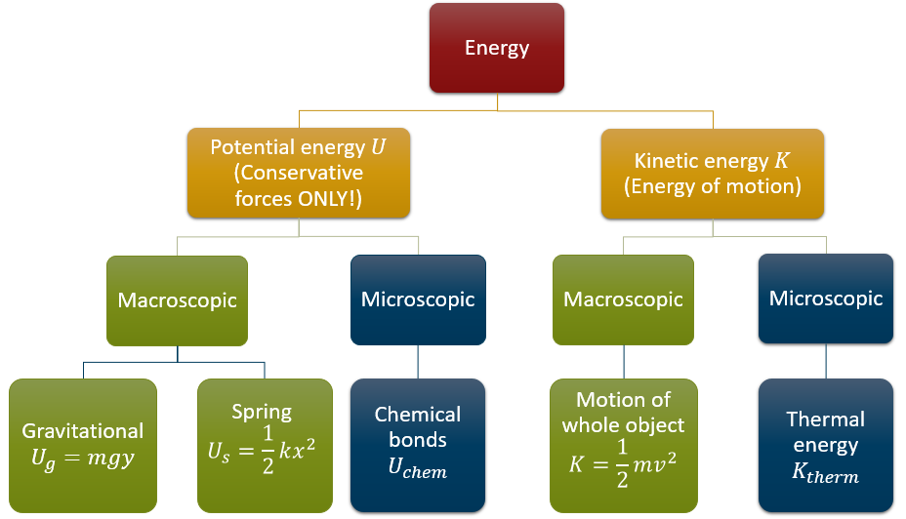

***FIGURE:*** *The different types of energy classified as microscopic and macroscopic*

## 15.1 Potential Energy of Molecules

As stated in the introduction, the primary source of microscopic potential energy with which we shall concern ourselves is the potential energy stored in chemical bonds or chemical potential energy . This potential energy is a result of the force of electrical attraction between different atoms (recall electricity and magnetism was one of our fundamental forces). As you shall see in the next course, the electrical force is a conservative force and thus we can associate a potential energy with it.

The strength of chemical bonds is typically quoted in one of two ways: either the energy in the bond is quoted directly (typically in eV) or the enthalpy per mole will be quoted. Let’s see how we can use these two different ways of quoting chemical energy and convert the result into something we can use.

### 15.1.1 Example: Bond energy expressed in eV

Back in chapter 13, we saw that the bond dissociation energy of the H-H bond was 4.52 eV/bond. How much energy is released by converting 2g of H2 into 2g of monatomic hydrogen?

### 15.1.2 Example: Bond energies expressed as enthalpies

Asdf

### 15.1.3 Example: Using bond energies to calculate heat released by a reaction

## Thermal Energy and Temperature

Thermal energy is the energy that an object has due to its temperature.

### Macroscopic Temperature

Kelvin scale, Celsius scale, absolute zero

### Microscopic Temperature

So what is temperature? Temperature is, in essence, a measure of the average kinetic energy of molecules. However, there is a bit of a complication. When I add energy to a molecule I can put it in a bunch of different places or *degrees of freedom*.

Examples of degrees of freedom

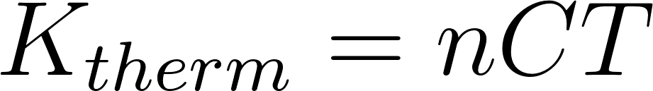

## Application of Conservation of Energy at the Microscopic Scale

1. “Bond-Dissociation Energy - Wikipedia.” Accessed August 1, 2017. https://en.wikipedia.org/wiki/Bond-dissociation_energy.
2. *File:Food Label from The Co-Opertative Food Sausages.Jpeg - Wikimedia Commons*. Photograph, June 8, 2015. https://commons.wikimedia.org/wiki/File:Food_label_from_The_Co-opertative_Food_Sausages.jpeg.
3. SteveBaker. *English: A 2007 MINI Cooper’S Car Shown Immediately before - and Soon after - a Severe Car Crash. At: Lat/Long 31.03669,-97.470881*, February 9, 2009. Own work. https://commons.wikimedia.org/wiki/File:BeforeAndAfterMINICooperS.png.